URINARY SYSTEM
The basic structural and functional unit of the kidney is the nephron. Each kidney has about 1 million nephrons, all packed into an area of the kidney called the cortex. The nephron's primary function is to filter blood, but as you can see from the diagram, this is not a simple process. The nephron has three major parts: the glomerulus, the Bowman's Capsule, and the tubule (which is further divided into the promimal and distal tubule and the Loop of Henle).
Blood enters the kidney from the renal artery and moves into the glomerulus, where filtration occurs. Filtration is the process by which water and dissolved particles are pulled out of the blood. The resulting liquid, called filtrate contains water and many of the toxic substances that might have accumulated in the blood (like ammonia). The glomerulus is enclosed by the Bowman's capsule, small molecules and water can pass through this area, but larger molecules do not. The filtrate is then collected in the Bowman's capsule for transport through the nephron.
The nephron itself will restore vital nutrients and water back into the blood, while retaining the waster products the body needs to eliminate. Two processes accomplish this task: tubular reabsorption and tubular secretion. During tubular reabsorption, cells in the proximal tubule remove water and nutrients from the filtrate and pass them back into the blood, wastes such as urea are retained in the tubule. During tubular secretion, wastes that were not initially filtered out in the bowman's capsule are removed from the blood in the distal tubule. Ammonia and many drugs are removed from the blood during tubular secretion.
The concentrated filtrate moves into the proximal tubule. Notice the capillaries that wrap around the tubules. At the points of contact with the tubule and the capillaries, water and nutrients are reabsorbed into the blood. In addition, wastes remaining in the blood after filtration are passed to the tubule. The filtrate flows from the proximal tubule and into the Loop of Henle. The loop of henle concentrates the filtrate, by removing more water from it, and passes it to the distal tubule. From the distal tubule it travels to the collecting duct - now called urine. The collecting duct prepares the urine for transport out of the body, it is collected in the renal pelvis where it eventually enters the ureter. From there it goes to the bladder.
Meanwhile, the blood capillaries that are twisted around the nephron join back to the renal vein, from there the blood travels to the posterior vena cava, eventually reaching the heart where it is oxgenated, but that is a topic for the "Circulatory System".
Coloring Instructions
1. Color the renal artery red, and continue the flow of blood through the capillaries. It will remain red until it reaches the area of the Loop of Henle, then the blood is deoxygenated, and should be colored blue. The renal vein should be colored blue, tracing its path until the blue capillaries meet the red capillaries (near the loop of henle). You'll have to be careful when coloring the arteries and veins, as they are twisted about the entire nephron. Also note that the blood from the renal artery enters the glomerulus and then exits again, to twist around the distal tubule. The capillaries should be colored purple, to show the mixing of the blood (blue and red make purple)
2. Color the renal vein (blue) and the renal artery (red) on the kidney as well as the nephron.
3. Color the proximal tubule dark green, until it reaches the loop of henle. The loop of henle should be colored pink, and then when it changes into the distal tubule, color the distal tubule light green.
4. Color the Bowman's capsule brown, leave the glomerulus white, you should have already colored the arteries inside it red.
5. Color both the collecting duct and the ureter yellow.
6. Color the medulla (there are 3 pictured) light green. Color the cortex pink, and the renal pelvis yellow. The nephron pictured on the kidney should be colored orange.

Name:______________________________________Date:_________
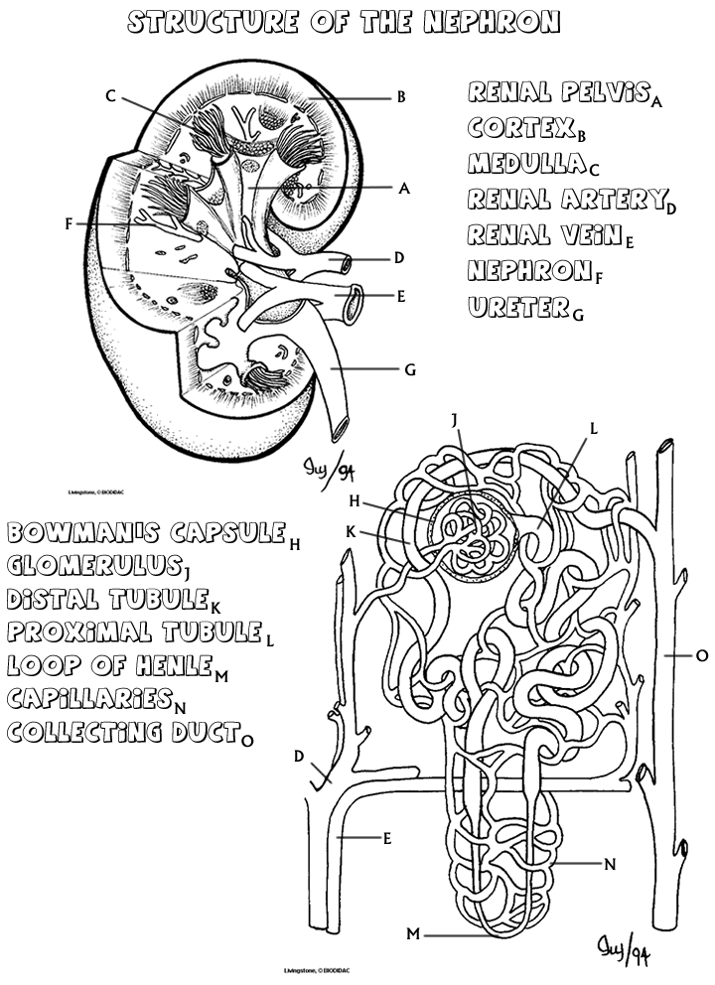

Questions
1. What is the function of the glomerulus and the bowman's capsule?
2. What is the function of the loop of henle?
3. Compare the processes of the distal tubule to the proximal tubule.
4. Describe the path the blood takes as it flows through the nephron.
5. Describe the path the filtrate takes as it flows through the nephron (beginning at the glomerulus).
6. Label the following nephron.
