The Teeth: Tooth Tales of Ripping, Grinding, and Tearing
Objective: | to observe the different ways teeth begin digesting foods
Student Information: | Chewing is the first step in the digestion of food. Baby teeth are called deciduous which means to fall off at maturity. Deciduous teeth cannot grow to fit the adult jaw, so they fall out and are replaced by secondary teeth.  Teeth are not bones. They are much stronger than bones. Each tooth is made up of four layers: the pulp (containing the nerves and blood vessels), the dentin (the hard inside), the enamel (the tough outer coating) and the cementum(the outer coating of the tooth's roots, which cements the tooth to the gums).  Types of human teeth: canine (sharp and pointy shapes used for cutting and tearing), incisors (big, flat wedge shapes used for biting food off), bicuspids (two-pointed shapes used for grinding) and molars (flat, squared shapes used for grinding).
Materials: | (for each student)  samples of foods such as apples, celery, leafy lettuce, nuts, raisins, cereal, pudding, cheese cubes, fruit leathers, peanut butter, prepared gelatin squares
Procedures: | 1. Have students eat samples of the different types of foods.  2. Ask - Did some foods require more chewing than others? Why? Which foods required tearing or grinding? Did any foods require no chewing at all? Why not?
Assessment: | Graphing  • On chart paper, create a graph entitled "Teeth Tales" with columns labeled RIPPING, GRINDING, TEARING.  • Have the students complete the graph by listing various foods under the correct column.

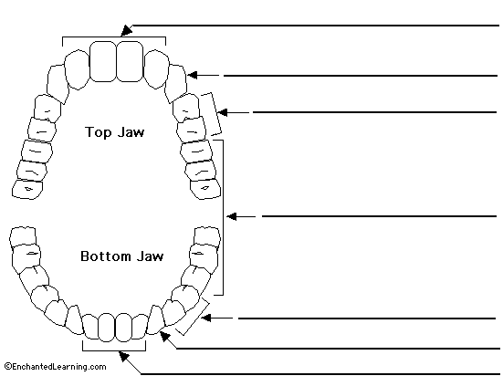

canine (also called cuspid) - the pointy tooth located between the incisors and the premolars. A canine tooth has 1 root. Adults have 4 canine teeth (2 in the top jaw and 2 in the bottom jaw). Canine means, "of or like a dog."
incisors - the front teeth, used for cutting food. An incisor has 1 root. Adults have 8 incisors (4 in the top jaw and 4 in the bottom jaw).
premolars (also called bicuspids) - the teeth located between the canine and the molars. A premolar tooth has 1 root. Bicuspids have two points (cusps) at the top. Adults have 8 premolars (4 in the top jaw and 4 in the bottom jaw).
molars - the relatively flat teeth located towards the back of the mouth, used for grinding food. Molars in the top jaw have 3 roots; molars in the lower jaw have 2 roots. Adults have 12 molars (6 in the top jaw and 6 in the bottom jaw).

Bone - the hard supportive tissue in which the tooth's root is anchored.  Crown - the visible part of a tooth.  Dentin - the hard but porous tissue located under both the enamel (and cementum) of the tooth. Dentin is harder than bone.  Enamel - the tough, shiny, white outer surface of the tooth.  Gum - the soft tissue that surrounds the base of the teeth. | Nerves and Blood Vessels - nerves transmit signals, and blood vessels carry nutrients to the tooth - they run through the tooth's root within the pulp.  Pulp - the soft center of the tooth. The pulp contains blood vessels and nerves; it nourishes the dentin.  Root - the anchor of a tooth that extends into the bone of the jaw. The number of human tooth roots ranges from one to four.

