Genetics Study Guide
- The letters along the sides of the Punnett square represent the parents’ __________________.
- What is the purpose of the Punnett square?
- Describe the difference between genotype & phenotype.
- Describe the difference between homozygous & heterozygous.
- A couple has two children, both of whom are boys. What is the chance that the parents' next child will be a boy?

- A female guinea pig homozygous dominant for black fur color is mated with a male homozygous for white fur color. What are the possible offsprings?

- The alternative forms of a trait are known as ________________________.
- A white mouse whose parents are both white produces only brown offspring when mated with a brown mouse. The white mouse is most probably _____.

- In mink, brown fur color is dominant to silver-blue fur color. If a homozygous brown mink is mated with a silver-blue mink and 8 offspring are produced, how many would be expected to be silver-blue?

- List the nucleotide pair bonds found in a DNA molecule.
- List the nucleotide pair bonds found in a RNA molecule.
- What components make up the backbone of a DNA molecule? Of an RNA molecule?
- Who suggested that the DNA molecule is the shape of a double helix?
- Describe the process of DNA replication with a detailed account of all the enzymes.
- Describe the process of the formation of Messenger RNA.
- Using the figure below (11-1), answer the following questions:
  - In which part of the cell does this process take place?
  - Which structures are composed of RNA?
  - Structure I represents __________________________.
  - Structure II represents _________________________.
  - Structure III represents __________________________.
  - Structure IV represents _________________________.
  - The process illustrates __________________________.
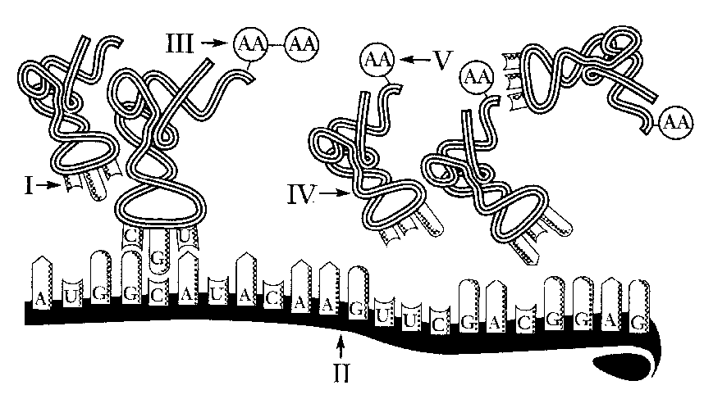
- What type of inheritance is shown when a red-flowering plant is crossed with a white-flowering plant & only pink-flowering plants are produced?

- Describe the difference between autosomes & sex chromosomes.
- Using the figure below (12-1), answer the following questions:
  - If individual III-2 marries a person with the same genotype as individual I-1, what is the chance that one of their children will be afflicted with hemophilia?

  - Individuals II-1 and II-4 in Figure 12-1 can be classified as _____.
  - What is the relationship between individual I-1 and individual III-2?
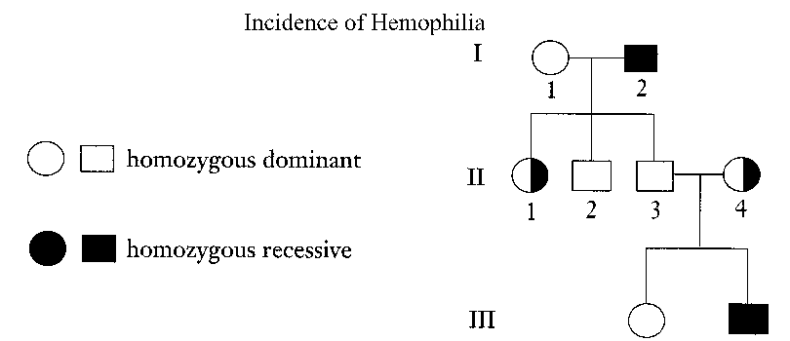

- If a female fruit fly heterozygous for red eyes (X^{R}X^{r}) crossed with a white-eyed male (X^{r}Y), what percent of their offspring would have white eyes?

- Both hemophilia & red-green color blindness are considered _______________________ trait and inherited only from the _______________________.

- List the phenotypes (blood type) for the following genotypes:

  - I^{A}I^{A}
  - I^{A}i
  - I^{B}I^{B}
  - I^{B}i
  - I^{A}I^{B}
  - ii

- Watson and Crick called the three-dimensional shape of DNA a ____________________________.
- The process of converting RNA code into an amino acid sequence is called _________________________.
- The molecule ______________________ brings amino acids to the ribosomes for the assembly of proteins.
- Each set of three nitrogen bases representing an amino acid is referred to as a(n) ____________________.
- The process by which DNA makes a copy of itself is called __________________________________.
- During the process of transcription, DNA serves as the template for making ____________________, which leaves the nucleus and travels to the ribosomes.

- Traits controlled by genes located on the X or Y chromosome are ____________________.
- Humans have 22 pairs of ____________________ type of chromosomes.
- A graphic representation of an individual's family tree is a(n) ____________________.
- Identify the terms for the following statements:
  - A cross involving two different traits
  - The exchange of genetic material between homologous chromosomes
  - The uniting of the male and female gametes
  - The cell produced when a male gamete fuses with a female gamete
  - The type of cell division that produces gametes
  - A cell that contains one member of each chromosome pair
  - The alleles present for a trait are the same
  - The passing of characteristics from parents to offspring
- In guinea pigs, the allele for rough coat (R) is dominant to the allele for smooth coat (r), and the allele for black fur (B) is dominant to the allele for white fur (b). If two guinea pigs that are heterozygous for rough, black fur (RrBb) are mated, what are the possible phenotypes and what is the frequency of each? Show your work in a Punnett square.

