**Skeletal & Muscular Systems Study Guide**

1. List the structure, function and location of cardiac muscle.
2. List the structure, function, and location of smooth muscle.
3. List the structure, function, and location of skeletal muscle.
4. Describe the movement and location of the following joints:
   1. Pivot
   2. Ball-and-socket
   3. Saddle
   4. Hinge
   5. Gliding
   6. Ellipsoid
5. Explain the structure of the long bone.
6. Define & describe the process of osteogeneis.
7. Illustrate the structure of the muscle down to the simplest filaments.
8. Explain the Sliding Filament Theory.
9. Define the following terms:
   1. Hypertrophy
   2. Atrophy
   3. Flaccidity
   4. Joint
   5. Keratin
   6. Myofibril
   7. Marrow
   8. Sarcomere
   9. Tendon
   10. Melanin
   11. Osteoblast
   12. Ligament
10. List the criteria used for naming muscles. List several examples for each criterion.
11. Describe the communication between the neuromuscular junction & muscle fibers.
12. List & illustrate the several types of bone fractures.
13. Identify the type of movements
    1. Abduction
    2. Adduction
    3. Pronation
    4. Supination
    5. Eversion
    6. Inversion
    7. Flexion
    8. Extension
14. List the functions of the following muscles:
    1. Gluteus medius
    2. Sartoris
    3. Rectus abdominis
    4. Deltoid
    5. Biceps brachii
    6. Gluteus maximus
    7. Sternocleidomastoid
    8. Diaphragm
    9. Rectus femoris
    10. Gastrocnemius
    11. Trapezius
    12. Intercostals
    13. Orbicularis oris
    14. Triceps brachii
    15. Pectoralis major

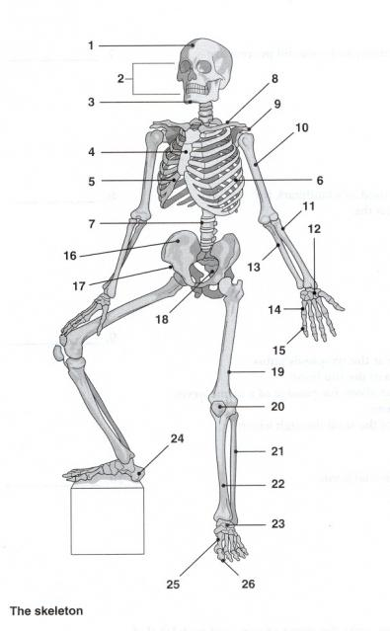Label the following bones: