Prokaryote Coloring
Prokaryotes cells are the simplest of all the cells. Bacteria are prokaryotes and they fall into two major categories: The Kingdom Eubacteria and the Kingdom Archaebacteria. Eubacteria are common types that occur all around us, usually they are on surfaces and in the soil. You can only find Archaebacteria in extreme environments, like hot sulfur springs. Archaebacteria are thought to be some of the oldest life forms on earth. Most bacteria don't make their own food. That means they have to rely on other organisms to provide them with food. These bacteria have to break down, or decompose, other living things to obtain energy.
When most people hear the word bacteria, they think of something that is bad for you. In fact, very few bacteria cause illness. Some bacteria actually help you! Bacteria are used to make food, such as cheese and yogurt, and they can also help us break down harmful substances in the environment. Scientists created a type of bacteria that could gobble up oil from oil spills. Some bacteria live inside the guts of animals and help them to digest food.
Unfortunately, there are many types of bacteria that can make us ill. Salmonella bacteria can cause food poisoning, and certain types of bacteria are responsible for other infections. You might have had some experience with Streptococcus, the bacteria that causes strep throat.
Bacteria have a very simple cell design. Most of them have a thick outer covering called the cell wall. On the picture, color the cell wall purple (it’s the outermost layer). Just within the cell wall is the cell membrane. Color the cell membrane pink. Along the surface of the bacteria cell, you might encounter structures called pilus, whose job is to help the bacteria stick to surfaces. Color all the pilus light green. Bacteria might also need to move around in their environment, so they can have structures called flagella, which resemble tails. Find the two flagella pictured and color them dark green. The watery interior of the cell is called cytoplasm, and it has the texture of jello. Color the cytoplasm light blue. Sprinkled throughout the cell are small roundish structures called ribosomes. Ribosomes make proteins for the cell. Color all of the ribosomes red. Every prokaryote cell has DNA floating within the cytoplasm, which usually looks like a twisted strand of spaghetti. DNA contains the instructions for the cell, basically it is the control center. Find the DNA and color it yellow.

Questions:
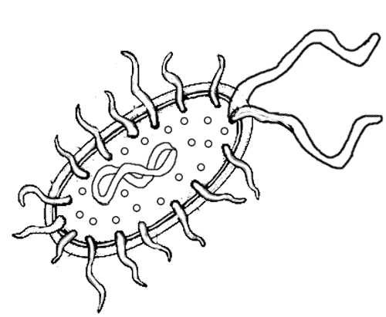
1. What bacteria causes strep throat? _________________
2. What are the oldest life forms on earth? ______________________
3. What type of bacteria causes food poisoning?____________________
4. What part of the bacteria cell helps it stick to surfaces?_____________
5. Name two foods that bacteria help make:_____________________
6. What does “decompose” mean?
________________
7. What is the control center of the bacteria cell?_________________
8. What part of the bacteria cell helps it move?___________________
9. Where do Archaebacteria live?
___________________
10. To what kingdom do common bacteria belong? _______________

