Name: ____________________________________ Block: ________ Date: ____________________

**Population Ecology Graph Worksheet**

**Directions:** Look at the graphs below and answer the following questions.

**Graphs 1 - Exponential Growth and Carrying Capacity**



1. Which of the two curves exhibits exponential growth? _______________________________

2. Which of the two curves exhibits a carrying capacity? _______________________________

3. What is the carrying capacity of this graph? _____________________________

4. In what generation does this population reach its carrying capacity? __________________________

**Graph 2**



1. For what type of organism is the carrying capacity shown? _______________________________

2. Give one possible reason why the population decreased in 1990 after it had reached its carrying

capacity. ___________________________________________________________________________

3. Give one hypothesis to explain why the population exceeded its carrying capacity in 1992.

___________________________________________________________________________________

4. Why did the population decrease in 1994 after it exceeded the carrying capacity? ________________

___________________________________________________________________________________

**Graph 3- Survivor Graphs**

Graph 3 shows 4 different growth curves- A, B, C & D.

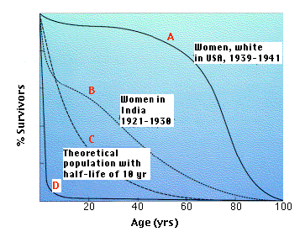

**Curve A** shows a white woman’s life expectancy in the USA.

**Curve B** shows an Indian woman’s life expectancy in India.

**Curve C** shows fish’s life which has an equal chance of dying at any age.

**Curve D** shows an oyster’s life in which there are many young but few survive to adulthood.

1. Who has a better chance of surviving infancy - Indian or American women? _____________________

2. At what age are most oysters dead? __________________________

3. At what age are most fish dead? ___________________________

4. Look at Curve A. Notice that it levels off between the ages of 20-40. What does this mean?

___________________________________________________________________________________

5. Which has a longer life expectancy - fish or oysters? ___________________________

**Graph 4 - Competition Curve**

Graph 4 shows the growth of 2 species of bacteria grown on the same petri dish. It also shows their growth rate when grown separately.

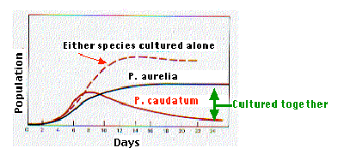

1. Which of the 2 types of bacteria will soon die? Why? _______________________________________

___________________________________________________________________________________

2. Which of the 2 bacteria strains is better adapted for competition? _____________________________

3. How is the growth rate for P. caudatum different when it is grown alone? _______________________

___________________________________________________________________________________

4. What happens to the growth rate of P. aurelia around day 12? _______________________________

___________________________________________________________________________________

**Graph 5 – Predator-Prey Graph**

Isle Royale National Park on a remote island was established in 1940, and designated a wilderness area in 1976. The only mode of transportation available is by boat or seaplane. Moose first arrived at Isle Royale around 1900. The moose population tends to increase in years with mild winters, early spring green-up, abundant winter forage, low wolf numbers and low levels of tick infestation. Wolves first arrived at the island on an ice bridge from Canada in 1940. Disease has also influenced the wolf population. Between 1980 and 1982, the wolf population declined from 50 to 14, due to canine parvovirus.

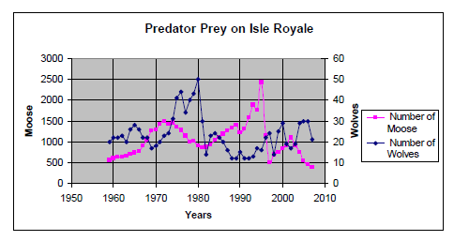

1. What is the greatest moose population? What year did that occur? What was the wolf population when

the moose population the greatest? ______________________________________________________

___________________________________________________________________________________

2. What would happen to the wolf population if the moose population decreases? __________________

___________________________________________________________________________________

3. What would happen to the moose population if the wolves were removed from Isle Royale?

___________________________________________________________________________________

4. Describe the pattern between the wolf (predator) population in relation to the moose (prey) population.

___________________________________________________________________________________

5. Identify a factor, other than moose population, that has influenced the wolf population in Isle Royale.

___________________________________________________________________________________

6. Identify two factors, other than the wolf population, that may influence the moose population.

___________________________________________________________________________________

___________________________________________________________________________________

7. Isle Royale has been undeclared as a national park and has been purchased by a large resort.

Describe one positive and one negative impact on the Isle Royale ecosystem. _____________________

___________________________________________________________________________________

___________________________________________________________________________________

8. Are predator-prey relationships density-dependent or density-independent limiting factors? Explain.

___________________________________________________________________________________

___________________________________________________________________________________