- Describe the steps of the cell cycle.

- List all the possibilities that may cause cancer.

- Describe what happens in prophase of mitosis.

- Describe what happens in metaphase of mitosis.

- Describe what happens in anaphase of mitosis.

- Describe what happens in telophase of mitosis.

- What is the longest phase of the cell cycle?

- Compare and contrast a somatic cell and a gamete cell.

- Describe the process of meiosis.

- List the function of the centromere.

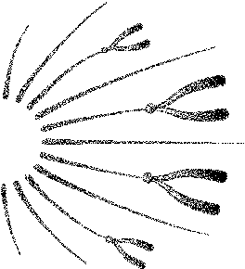
- The chromosomes shown are in which state of mitosis?

- Chlorophyll traps __________from sunlight.
- Energy is released from ATP when the bond is broken between ______________.
- In glycolysis, _____ molecules of ATP are used in the first step, and _____ molecules of ATP are produced in the second step.

- What is the equation for photosynthesis?

- How does the cell store energy? How does the cell release energy?

- Draw a diagram demonstrating how energy is produced in a cell (Hint: ATP & ADP).

- In meiosis, when does crossing over take place?

- What is the purpose of crossing over?

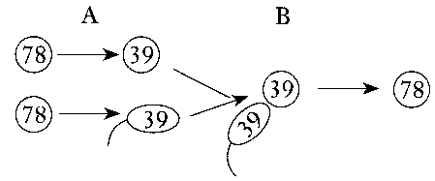
- The numbers in Figure 10-1 represent the chromosome number found in each of the dog cells shown. The processes that are occurring at A and B are _____.

- Describe the process of photosynthesis.

- Which step is oxygen released?
- Why does the organism need a way of storing energy?

- The structures that hold together sister chromatids are ____________________.
- The process by which nuclear material is divided equally between two new cells is ____________________.
- The uncontrolled division of cells that results in a malignant growth is known as ____________________.
- The two halves of a doubled chromosome structure are called ____________________.
- The sequence of growth and division of a cell makes up the ____________________.
- The phase of mitosis in which the sister chromatids separate from each other is ____________________.
- In photosynthesis, the series of reactions that synthesize simple sugars from carbon dioxide and hydrogen is known as the ____________________.

- The anaerobic process of splitting glucose to form pyruvic acid is called ____________________.
- The process by which autotrophs use energy from sunlight to build carbohydrates is called ____________________.

- Define the following terms:
a. | crossing over | e. | haploid
b. | meiosis | f. | homozygous
c. | dihybrid | g. | zygote
d. | heredity | h. | fertilization

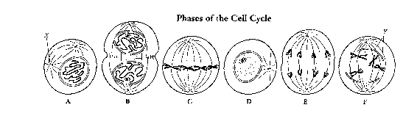
Figure 8-3

32. Sequence the six diagrams in Figure 8-3 in order from first to last, beginning with D.

33. Cells A and F of Figure 8-3 show an early and a late stage of the same phase of mitosis. What phase is it?

34. Which cell of Figure 8-3 is in metaphase?

35. Cytokinesis is the division of the cytoplasm when a cell divides. In precisely which phase of the cell cycle does cytokinesis occur?

36. Compare and contrast the terms aerobic process and anaerobic process.

38. How is energy stored in ATP?

39. How does meiosis maintain a constant number of chromosomes in the body cells of organisms that reproduce sexually?

40. Explain how crossing over in meiosis results in genetic variation.

41. If you run or ride a bicycle as fast as you can, your muscles may begin to feel weak and have a burning sensation. Explain what is occurring that accounts for this muscle fatigue.

