Phases of Meiosis
Name of Phase | Description
1. | Homologous chromosomes pair up and form tetrad
2. | Spindle fibers move homologous chromosomes to opposite sides
3. | Nuclear membrane reforms, cytoplasm divides, 4 daughter cells formed
4. | Chromosomes line up along equator, not in homologous pairs
5. | Crossing-over occurs
6. | Chromatids separate
7. | Homologs line up alone equator
8. | Cytoplasm divides, 2 daughter cells are formed
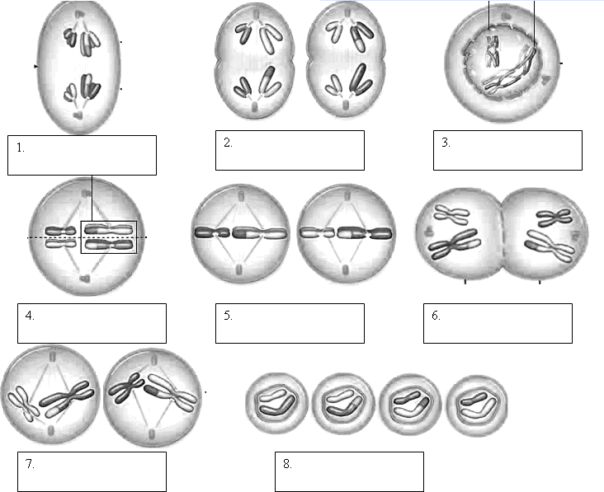

- Describe the structure of a chromosome.
- How do the end products of meiosis differ from the end products of mitosis?
- Explain the role of crossing-over in ensuring genetic variation
- State the number of chromosomes in normal human cells.
- What is the difference between haploid cells and diploid cells?
- Contrast sex chromosomes with autosomes.
- During which stage of meiosis is the diploid number of chromosomes reduced to the haploid number of chromosomes?

- Crossing-over occurs during which phase?
- How does cytokinesis differ between plants and animals?
- Compare and contrast each stage of mitosis and meiosis.
Stages | Mitosis | Meiosis
End Product

