Parts and Functions of the Nervous Systems
Structure | Location | Function
Cerebrum
Diencephalon
Brainstem
Midbrain
Pons
Medulla
oblongata
Cerebellum
Corpus callosum
Color and label the above structures below.

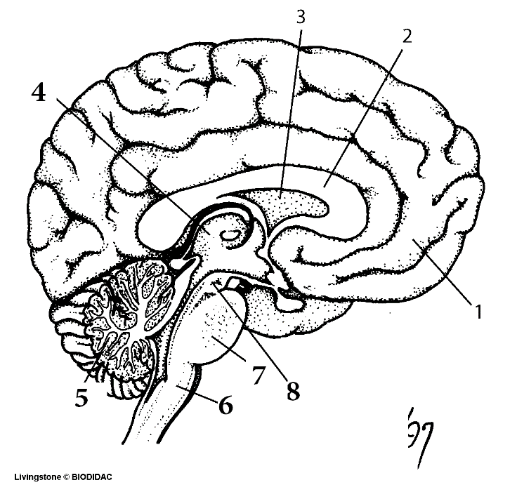
LOBES OF THE BRAIN
Color and label the lobes of the brain on the diagram below and identify each lobes function.

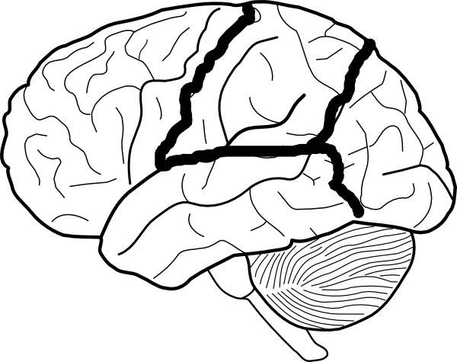
LOBE | Functions
Frontal

Parietal

Temporal

Occipital

