Overview of the Circulatory System
Fill in the blanks to trace the path of blood through the circulatory system
From the right atrium to the (1) ____ through the (2)_ ___ valve to the pulmonary trunk to the right and left (3)____, to the capillary beds of the (4) ____, to the (5) ___, to the (6) ____ of the heart through the (7) ___ valve, to the (8) _____ through the (9) ____ semilunar valve, to the (10) ___, to the systemic arteries, to the (11) ___ of the body tissues, to the system veins, to the (12) ____ and (13) ____, which enter the right atrium of the heart.
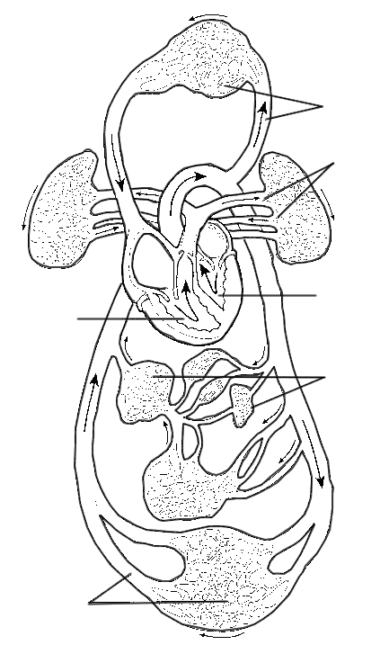
1. ____________________________________
2. ____________________________________
3. ____________________________________
4. ____________________________________
5. ____________________________________
6. ____________________________________
7. ____________________________________
8. ____________________________________
9. ____________________________________
10. ____________________________________
11. ____________________________________
12. ____________________________________
13. ____________________________________
Label the Diagram
A - Vessels serving the head and upper limbs
B - Vessels serving the body trunk and lower limbs
C - Vessels serving the viscera
D - Pulmonary Circulation
E - Pulmonary "Pump"
F - Systemic "Pump"

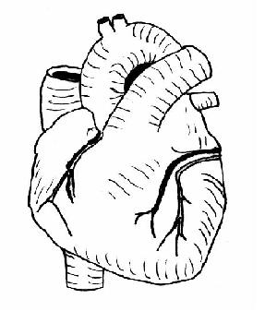

- Label the following picture.
- Color the vessels that bring blood to the body red.
- Color the vessels that bring blood to the heart blue.
- Draw the direction of blood flow.
