- What makes up the central nervous system?
- What makes up the peripheral nervous system
- The whitish fatty segmented covering of axons that acts as electrical insulation is called _________________________________.
- The space between nerve fibers is called __________________________________.
- Fill in the table below to indicate the functions of the parts of the brain.
Part | Function
Cerebrum
Thalamus
Hypothalamus
Cerebellum
Medulla oblongata
Frontal Lobe
Parietal Lobe
Temporal Lobe
Occipital Lobe

- Label the diagram of a neuron below:
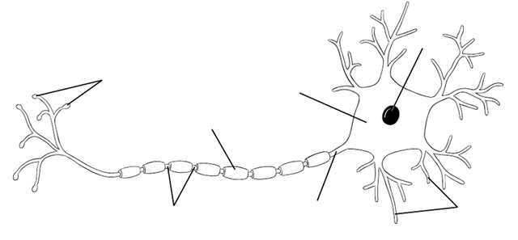
- Label the diagram of a chemical synapse below:
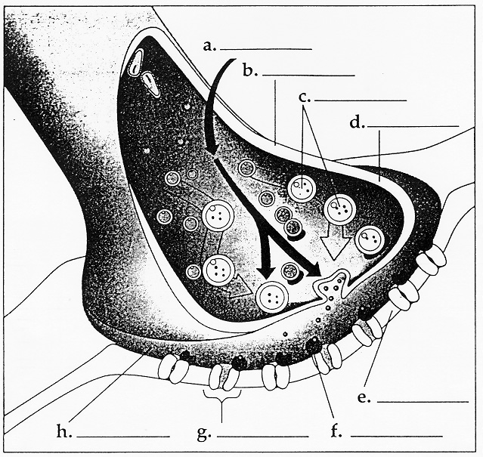
- Label the brain below:
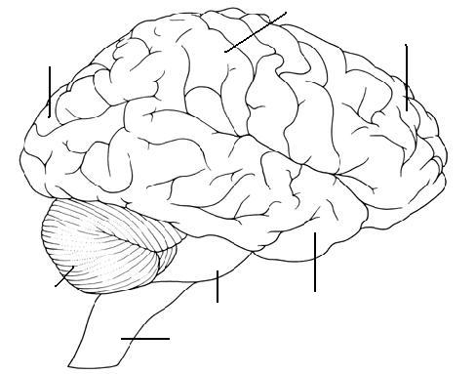
- What is the relationship between addiction and tolerance?

- How does a stimulant differ from a depressant?

- What are the 6 types of psychoactive drugs? (Table 49-2; page 1023)
Type of Drug | Examples

- List the risks associated with the use of psychoactive drugs.

