**Science Basics Test Review**

Why do we use graphs in science? ______________________________________________________

Why do we use the metric system in science? ______________________________________________

Convert the following:

82 meter = ____________ km 18 kilometers = _________ meters

5000 milliliters = __________ liters 652 grams = _________ kilograms

What is the difference between an observation and an inference? ____________________________________________________________________________________

What is the difference between qualitative and quantitative data? ____________________________________________________________________________________

What is the variable that the scientist is testing called? _________________________________

What is the variable that the scientist is measuring called? ______________________________

Why do you need a control variable in a scientific experiment? _________________________________

Why should you keep some things the same (constant) throughout a scientific experiment? ____________________________________________________________________________________

MC900234324[1]Study the picture and decide if each of the following statements in an inference or an observation.

There are 2 people in the picture. __________

There is a ship or boat. __________

The people are husband and wife. __________

The Sun is out. __________

It is hot outside. __________

Define the following terms:

Biology: __________________________________________________________________

Hypothesis: _______________________________________________________________

Theory: __________________________________________________________________

Scientific law: _____________________________________________________________

Independent variable: _________________________________________________________

Dependent variable: __________________________________________________________

Control variable : ___________________________________________________________

Constants : _______________________________________________________________

Write the steps to the scientific method in order. ____________________________________________________________________________________

Can a scientific theory ever be changed? Explain. ____________________________________________________________________________________

Tell whether each of the following is quantitative data or qualitative data.

5 apples: ________________________

A green slime was present: ________________________

All the bubbles are gone: ________________________

It took 62 minutes: ________________________

The solution turned light blue: ______________________

**Use the following paragraph to answer questions the following questions.**

A scientist is interested in testing the affects of a chemical on apple production in an orchard. The new chemical is supposed to increase apple production. He sprays the chemical half of the orchard. The other half does not receive the chemical spray. In the fall, the number of apples harvested from each side of the orchard is counted. 2578 apples were harvested from the side of the orchard which was sprayed with the chemical. 2625 apples were harvested from the side of the orchard which was not sprayed with the chemical.

What is the scientist’s hypothesis? _________________________________________________

What is the independent variable? _________________________________________________

What is the dependent variable? __________________________________________________

What is the control variable? ____________________________________________________

What are the constants? _______________________________________________________

What should the scientist’s conclusion be? ___________________________________________

Compare and contrast *organism* and *species*.

Compare and contrast *growth* and *development*.

Compare and contrast *stimulus* and *response*.

Although reproduction does not guarantee the survival of an individual organism, all living things reproduce. What purpose does reproduction serve?

The graph in Figure 1-2 shows the three stages in the growth of a corn plant from a seed to a mature plant. Study the graph and then answer the questions.

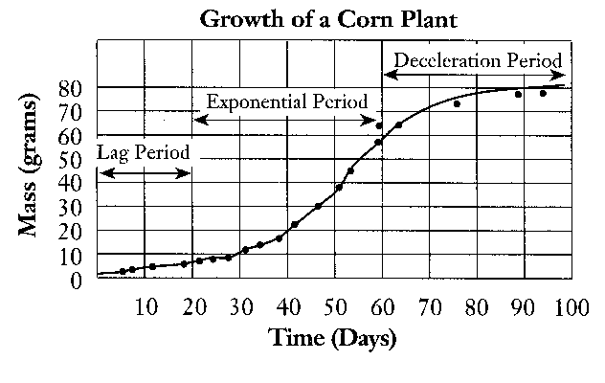

**Figure 1-2**

From Figure 1-2, predict the mass of the plant at day 110.

Describe the growth rate of the plant during the final stage compared with the rate during the exponential period, as shown in Figure 1-2.

Using Figure 1-2, what is the mass of the plant at day 50?

Compare and contrast *independent variable* and *dependent variable*.

Define the following terms:

|  |  |  |
| --- | --- | --- |
| development | d. | evolution |
| adaptation | e. | reproduction |
| Homeostasis  Law | f. | Environment  Theory |

The language used for scientific names is ____________________ because it does not change.

Scientists used a system of ____________________ to help understand the relationships between organisms.

Describe the characteristics of life.

List the levels of organization starting with the simplest form of matter.