Mollusk Discovery Name ______________ Period ___
Use Mollusks at Enchanted Learning (www.enchantedlearning.com), reference books, your science textbook, or the pictures to help you answer the questions.
Bivalves 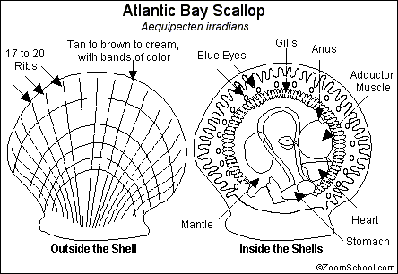
- List five key words that describe this organism
(for example: does it have a shell, foot, special feature, etc.)
What does this scallop eat? What eats the scallop?
- Give an example of an unusual or interesting trait that the scallop possesses.
(think about defense, coloring etc.)
- How does the scallop move?
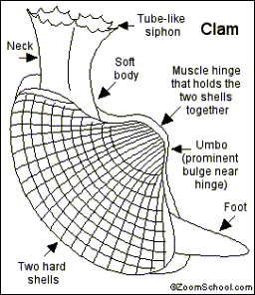
- List five key words that describe this clam.
(for example: does it have a shell, foot, special feature, etc.)
What does this clam eat? What eats the clam?
- Give an example of an unusual or interesting trait that the clam possesses
(think about defense, coloring etc.)
- How does the clam move?
Gastropods (Univalves)
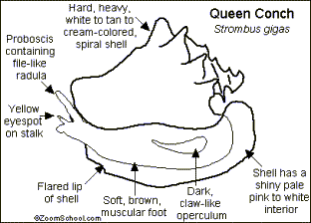
- List five key words that describe this conch.
(for example: does it have a shell, foot, special feature, etc.)
- What does this conch eat? What eats the conch?
- Give an example of an unusual or interesting trait that the conch possesses
(think about defense, coloring etc.)
- How does the conch move?
Gastropod (Univalve)
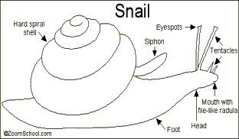
- List five key words that describe this snail.
(for example: does it have a shell, foot, special feature, etc.)
- What does this snail eat? What eats the snail?
- Give an example of an unusual or interesting trait that the snail possesses
(think about defense, coloring etc.)
- How does the snail move?
Cephalopods
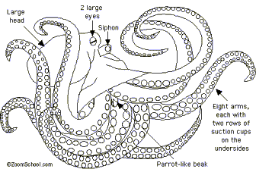
- List five key words that describe this octopus.
(for example: does it have a shell, foot, special feature, etc.)
- What does this octopus eat? What eats the octopus?
- Give an example of an unusual or interesting trait that the octopus possesses
(think about defense, coloring etc.)
How does the octopus move?
Cephalopods
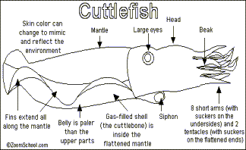
- List five key words that describe this cuttlefish.
(for example: does it have a shell, foot, special feature, etc.)
- What does this cuttlefish eat? What eats the cuttlefish?
- Give an example of an unusual or interesting trait that the cuttlefish possesses
(think about defense, coloring etc.)
- How does the cuttlefish move?

- Gastropod
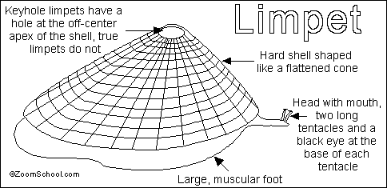
- List five key words that describe this limpet.
(for example: does it have a shell, foot, special feature, etc.)
- What does this limpet eat? What eats the limpet?
- Give an example of an unusual or interesting trait that the limpet possesses
(think about defense, coloring etc.)
- How does the limpet move?

