Name _____________________________________________ Period __________ Score ____________
Metric System vs. American System
Metric System Units America System Units
Weight : ____________________________ Weight: _________________________________
Length: _____________________________ Length: __________________________________
Volume: ____________________________ Volume: _________________________________
Temperature: ________________________ Temperature: ______________________________
Why do we use the metric system in Science? ____________________________________________________
The metric system is based on a _____________ ____________ that corresponds to a certain type of measurement.
Base Unit Abbreviation
Length = ______________________ _________
Volume = _____________________ _________
Weight = ______________________ _________
Comparisons:
Width of your finger nail = ____________________ Width of your finger = ____________________
Width of your hand = ____________________ Your arms outstretched = ____________________
Prefixes:
k = ________________ = thousand d = ________________ = one tenth
H = ________________ = hundred c = ________________ = one hundredth
D = ________________ = ten m =________________ = one thousandth
Metric Conversions

Practice:
- What is the length of the line in centimeters? ______________
- What is the length of the line in decimeters? ______________
- What is the length of the line in milimeters? ______________
- What is the length of the line in meters? ______________
Write the correct abbreviation for each metric unit.
- Kilogram __________ 4) Millimeter __________ 7) Kilometer__________
- Meter __________ 5) Milliliter __________ 8) Centimeter __________
- Gram __________ 6) Liter __________ 9) Milligram __________
Convert using the ladder method or × and ÷ method.
10) 2000 mg = __________ g 15) 5 L __________ mL 20) 16 cm = __________ mm
11) 104 km = __________ m 16) 198 g = __________ kg 21) 2500m = __________ km
12) 480 cm = __________m 17) 75 mL = __________ L 22) 65 g = __________ mg
13) 5.6 kg = __________ g 18) 50 cm = __________ m 23) 6.3 cm = _________ mm
14) 8mm = __________ cm 19) 5.6 m = __________ cm 24) 120 mg = __________ g

Example Experiment:
Smithers thinks that a special juice will increase the productivity of workers. He creates two groups of 50 workers each and assigns each group the same task (in this case, they're supposed to staple a set of papers). Group A is given the special juice to drink while they work. Group B is not given the special juice. After an hour, Smithers counts how many stacks of papers each group has made. Group A made 1,587 stacks, Group B made 2,113 stacks.
Hypothesis: _________________________________________________________________
Independent Variable: ______________________ Dependent Variable: _______________________________
Control Group: ___________________ Constants: ________________________________________________
Conclusion: _______________________________________________________________________________
Improvements: _____________________________________________________________________________
Observations vs. Inferences
Observation: ____________________________________________________________
Examples: _________________________________________________________
Qualitative Data: _________________________________________________________
Examples: __________________________________________________________
Quantitative Data: ________________________________________________________
Examples: _________________________________________________________
Inference: ________________________________________________________________________________
Examples: _________________________________________________________
Using the pictures shown in class, list as many observations and inferences you can about the pictures.
Observations Inferences Observations Inferences

Place an “O” next to all the statements that are observations and an “I” next to all the statements that are inferences
- __________There is a representation of a face on one side of the coin.
- __________The coin comes from a society of deeply religious people.
- __________The words “We Trust the Gods” are printed on the coin.
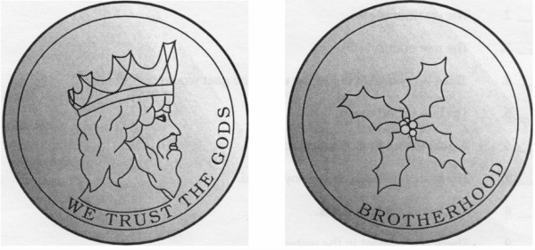
- __________One side of the artifact is a drawing of leaves.
- __________The artifact comes from peace loving people.
- __________The face on the coin is a representation of the people’s king.

Graphing Data
Why do we use graphs? ______________________________________________________________________
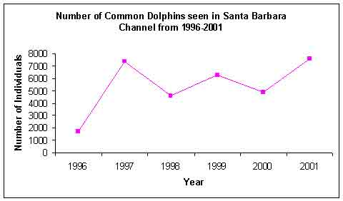
Use the graph on the right to answer the questions.
- What is the title of the graph? _______________________________ _______________________________
- What is the range of values on horizontal scale or x-axis (include units)? _________________________
- What is the range of values on the vertical scale or y-axis (include units)? _______________________________
- How many data points are represented in the graph? ______
- What year where the most dolphins seen in Santa Barbara? ________ how many were seen? ________
- What year where the least dolphins seen in Santa Barbara? ________ how many were seen? ________
- Has the number of dolphins increased or decreased over the 5 year span? _______________________

Use the data in the tables to make 3 different graphs. Be sure to name and label each graph.
Line Graph: _____________________________ Bar Graph: ______________________________
Student’s Favorite After School Activities
Activity | Number of Students
Play Sports | 45
Talk on the Phone | 53
Visit with Friends | 99
Earn Money | 44
Chat Online | 66
School Clubs | 22
Watch TV | 37

Adopt Student Uniforms Survey
Response | Number of Students | Percentage
Yes | 30 | 10%
No | 180 | 60%
Maybe | 90 | 30%

Pie Chart: __________________________________

Sam’s Weight
Month | Weight in kg
January | 49
February | 54
March | 61
April | 69
May | 73

