DNA & Protein Synthesis Study Guide

- Describe the base pairing rules in a DNA molecule

- The backbone of a DNA molecule is made of which two components?

- Who discovered that DNA was the shape of a double helix?

- Define the following terms:

  - Deletion

  - Nondisjunction

  - Translocation

  - Inversion

- Describe the process of DNA replication (include terms such as helicase, polymerase, single stranded binding proteins, okazaki fragments, ligase, leading strand, lagging strand).

- Describe the function of messenger RNA, transfer RNA, and ribosomal RNA.

- What is the subunits of DNA & RNA?

- In which part of the cell does this process shown in Figure 11-1 take place?

- Which of the structures in Figure 11-1 are composed of RNA?

- Structure III in Figure 11-1 represents a(n) _____.

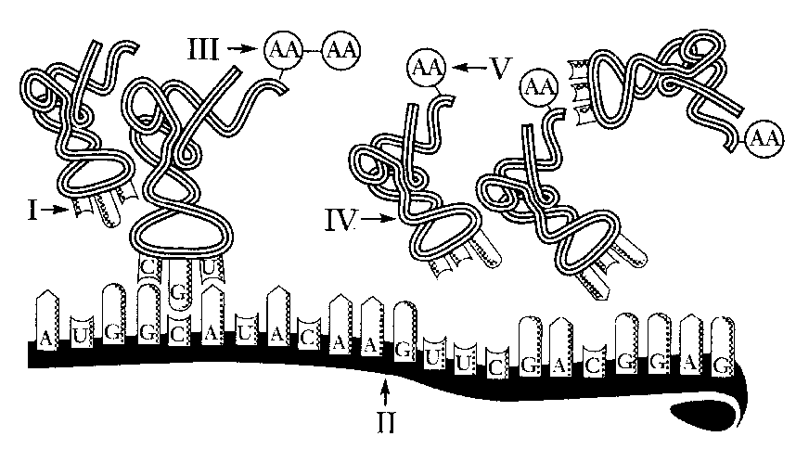
- The process illustrated in Figure 11-1 is called _____.

- A DNA segment is changed from-AATTAG- to -AAATAG-. This is a ____.

- A DNA segment is changed from -AATTAGAAATAG- to -ATTAGAAATAG-. This is a ____.

- The process of converting RNA code into an amino acid sequence is called ____________________.

- The molecule ____________________ brings amino acids to the ribosomes for the assembly of proteins.

- Each set of three nitrogen bases representing an amino acid is referred to as a(n) ____________________.

- Thymine, adenine, guanine, and cytosine are classified as ____________________.

- During the process of transcription, DNA serves as the template for making ____________________, which leaves the nucleus and travels to the ribosomes.

- When parts of chromosomes are broken off and lost during mitosis or meiosis, the result is a(n) ____________________.

- If a nucleotide is added or removed from a DNA molecule and mRNA is created, the codons after the mutation will not be read correctly. This is a ____________________.

- A change in a single base pair of the DNA molecule that affects the synthesis of an entire protein is called a(n) ____________________.

- Why is tRNA important in translation?

- In Figure 11-2, use the letter P to label all of the phosphate groups. Use an S to label all the sugar molecules. For labeling the nitrogen bases, use a T for thymine and a C for cytosine. Guanine and adenine have been filled in for you. Circle and label a codon. Circle and label a nucleotide.
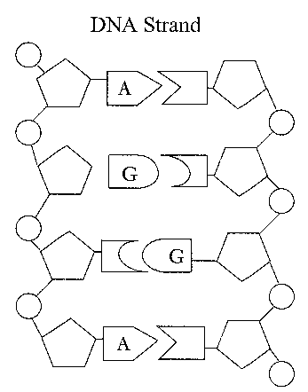Figure 11-2

