Chapter Review; Diffusion and Osmosis
What do you Know?
1. Label the three images below as isotonic/ hypertonic/ hypotonic (with regard to the solution the cell is placed in)
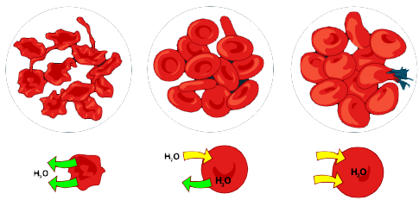
2. Movement across the cell membrane that does not require energy is called
[ active / passive ] transport.
3. The difference in the concentration of a substance across a space is called a concentration [ equilibrium / gradient ].
4. If there is a concentration gradient, substances will move from an area of high concentration to an area of [ equal / low ] concentration.
5. The cell membrane is [ selectively permeable / impermeable ].
6. [ Equilibrium / Diffusion ] is the simplest type of passive transport.
7. The diffusion of water through a selectively permeable membrane is called [ osmosis / diffusion ].
8. The direction of water movement across the cell membrane depends on the concentration of free water[ molecules / solutions ].
9. A solution that causes a cell to swell is called a [ hypertonic / hypotonic ] solution.
10. Organelles that collect excess water inside the cell and force water out are called
[ diffusion organelles / contractile vacuoles ]
11. The process of taking material into the cell by infolding the cell membrane is called [ endocytosis / exocytosis ]
12. In [ facilitated / molecular ] diffusion, membrane proteins help molecules across the membrane.
13. In diffusion, molecules [ spread out / condense ]
14. The lipid bilayer describes [ a type of transport / the cell membrane ]
15. Facilitated diffusion moves substances down their concentration gradient [ with / without ] using the cell's energy.
Review
- What are the parts of a solution (Solvent and solute)
2. Label a cell membrane (bilayer, proteins)
3. Explain what will happen to cells when placed in isotonic, hypertonic, and hypotonic solutions.
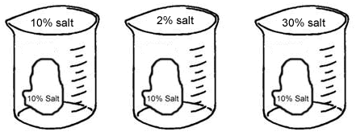
4. Define:
Diffusion
Equilibrium
Osmosis
Isotonic
Hypertonic
Hypotonic
Facilitated diffusion
Endocytosis
Phagocytosis
Pinocytosis
Exocytosis
5. Explain what happens when you place a bag full of starch (solution) into a solution of iodine.

