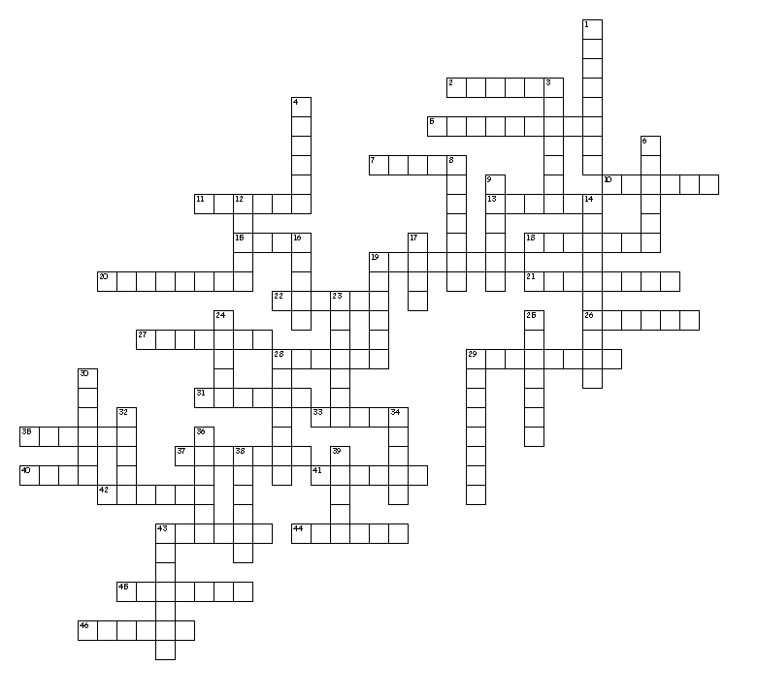

Across
2. behind; back; backward
5. brain
7. surrounding
10. disease
11. to cut
13. gland
15. under; below
18. kidney
19. clot
20. cancer
21. head
22. pain
26. white
27. heart
28. above; excessive
29. red
31. instrument for visual examination
33. study
35. produced by or in
37. mind
40. life
41. skin
42. nerve
43. sugar
44. knowledge
45. joint
46. secrete
Down
1. blood
3. protein
4. physician; treatment
6. bone
8. removal; excision
9. x-rays
12. to cut
14. umbilicus (navel)
16. record
17. urinary tract
19. across; through
23. female
24. inflammation
25. intestines
28. liver
29. electricity
30. nose
32. cell
34. tumor; mass
36. visual examination
38. urinary bladder
39. child; foot
43. stomach

