- Define and provide examples of a polymer.

- What element is found in all organic compounds?

- Which of the following is a chemical reaction?
a. | tearing paper into strips
b. | burning paper
c. | picking up iron filings with a magnet
d. | mixing salt and sugar in the same container

- Describe the structure of an atom.

- List the monomers (basic building block) for proteins, carbohydrates, lipids, nucleic acids.

- Water dissolves many ionic and molecular compounds because of its _____.

- An enzyme is an example of what organic molecule?

- Define isotope.

- Compare and contrast saturated fat with unsaturated fat.

- List the elements found in the molecules of life (carbohydrates, protein, lipids, nucleic acids).

- Define diffusion.

- Define Osmosis.

- Explain the meanings of Dynamic Equilibrium and Concentration Gradient.

- What type of cell has a cell wall?

- What are all living things made up of?

- List the components of the cell theory.

- Who discovered cells? Who first described living cells?

- Compare & contrast prokaryote & eukaryote.

- Why is the plasma membrane referred to as a fluid mosaic?

- List the components that make up the plasma membrane.
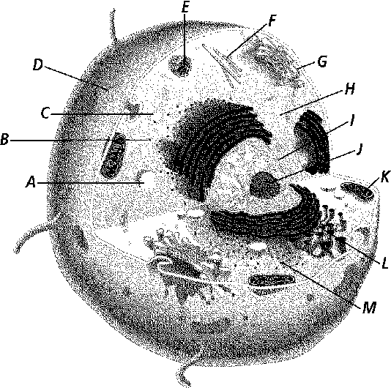

- Label the following diagram.

- List the function of each organelle in the previous diagram.

- What type of cell is the one shown. Explain.

- Water moves into a cell placed in a(n) _____ solution.

- Water moves out of a cell if the cell is placed in a(n) _____ solution.

- If cells are placed in a strong sugar solution, water will _____.

- If a cell is placed in salt water, water leaves the cell by _____.

- Why is the cell’s size limited?

- As a cell grows, its _____ increases more than its _____.

- Which conditions shown in Figure 8-4 might cause a cell to burst?

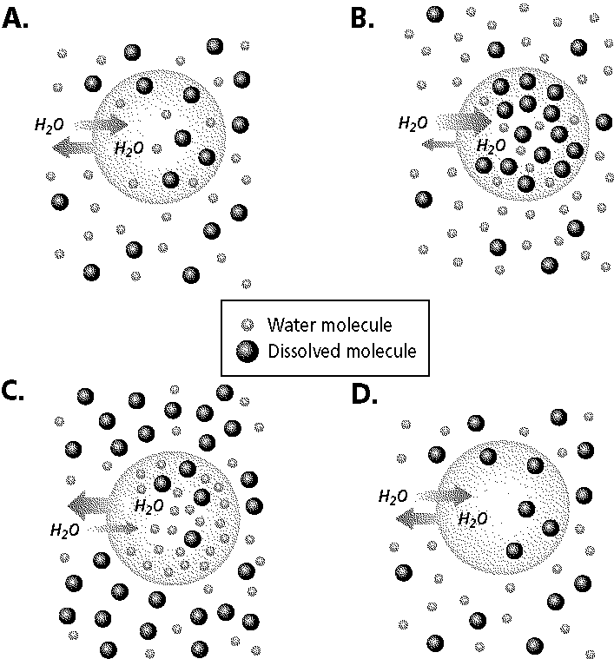

- The structure most responsible for maintaining cell homeostasis is the _____.

- List several examples of a lipid.

- List two examples of a nucleic acid.

- Define pH and explain the pH scale.

- Why does water dissolve many ionic and molecular compounds?

Complete each sentence or statement.

- An organic compound with a ratio of about two hydrogen atoms and one oxygen atom for each carbon atom is a(n) ____________________

- The smaller subunits that make up nucleic acids are ____________________.

- Two atoms that share electrons are held together by ____________________ bonds.

- Atoms of the same element with different numbers of neutrons are ____________________.

- Cell structures that contain digestive enzymes are ____________________.

- In a cell, the sites of protein synthesis are the ____________________.

- The movement of materials into and out of the cells is controlled by the ____________________.

- In a cell, the breakdown of molecules in order to release energy occurs in the ____________________.

- In plants, the structures that transform light energy into chemical energy are called ____________________.

- The network of tiny rods and filaments that forms a framework for the cell is called the ____________________.

- An organism with a cell that lacks a true nucleus is a(n) ____________________.

- A structure outside the plasma membrane in some cells is the ____________________.

Define the following terms:
a. | cellulose | e. | polymer
b. | polar molecule | f. | solution
c. | nucleus | g. | enzyme
d. | peptide bond | h. | metabolism

