Chapter 2
Medicine & its Specialties
PRINCIPAL WORD PARTS

Combining Forms
Algesi(o) | Sensitivity to pain
Bi(o) | Life or living
Cardi(o) | Heart
Crin(o) | To secrete
Dent(o), odont(o) | Tooth
Derm(a), dermat(o) | Skin
Esthesi(o) | Feeling
Ger(a), ger(o), geront(o) | Aged
Gynec(o) | Female
Hist(o) | Tissue
Immune(o) | Immune
Laryng(o) | Larynx
Neur(o) | Nerve or nervous system
Obstetr(o) | Midwife
Onc(o) | Tumor
Ophthalm(o) | Eye
Opt(o), optic(o) | Vision
Or(o) | Mouth
Orth(o) | Straight
Ot(o) | Ear
Path(o) | Disease
Ped(o) | Child or foot
Pharmac(o) | Drugs or medicine
Pharmaceut(o) | Drugs
Physi(o) | Nature
Plast(o) | Repair
Pod(o) | Foot
Psych(o) | Mind
Radi(o) | Radius or radiant energy
Rheumat(o) | Rheumatism
Rhin(o) | Nose
Therapeut(o) | Treatment
Tom(o) | To cut
Tox(o), toxic(o) | Poison
Ur(o) | Urine or urinary tract

Prefixes
An- | Not or without
Ana- | Up or again
End-, endo- | Inside
Pes- | foot

Suffixes
-ac,-al,-ic | Pertaining to
-crine | To secrete
-er, -ist | One who
-ia | Condition
-iatrician | Practitioner
-iatrics, -iatry | Medicine
-ism | Condition, theory, process
-logist | One who studies
-logy | Study or science of
-opsy | To view
-pod | Foot
-tomy | Incision (cutting)

Medicine & Its Specialties
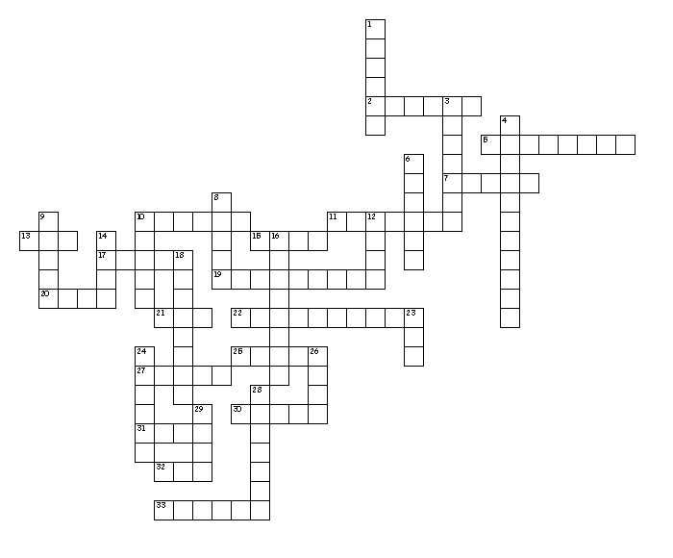

Across
2. Heart
5. Rheumatism
7. Nerve
10. Nature
11. Sensitivity to pain
13. Urine or urinary tract
15. Child
17. Straight
19. Eye
20. Tumor
21. Ear
22. Treatment
25. Nose
27. Skin
30. radiant energy
31. To cut
32. Life
33. Mind
Down
1. Female
3. Immune
4. Drugs
6. Repair
8. Tissue
9. To secrete
10. Disease
12. Aged
14. Foot
16. Feeling
18. Midwife
23. Mouth
24. Tooth
26. Vision
28. Larynx
29. Poison

