Cell Membrane Images
Instructions: For each image, determine an appropriate title and a description for what is happening in each.
TITLE: _____________________________________________
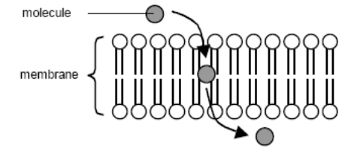
Description: _________________________________________
TITLE: _________________________________________________
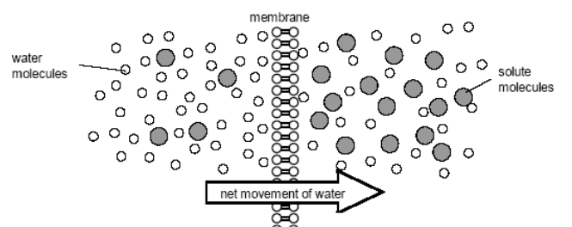
Description: _________________________________________________________________
TITLE: ________________________________________________________________
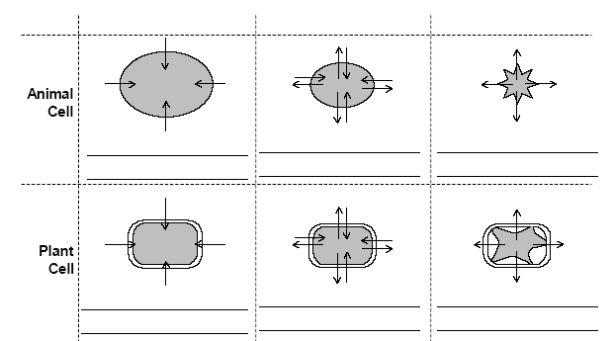
Description: ________________________________________________________________________
Title: _______________________
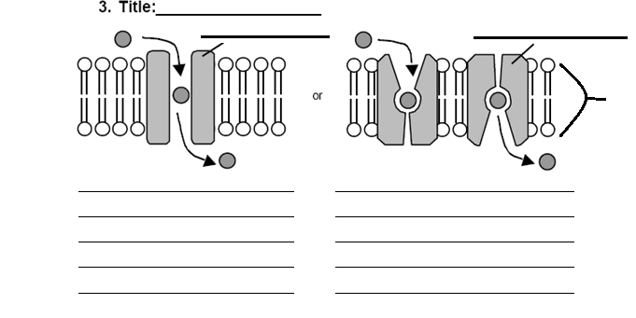
TITLE: _____________________________________________
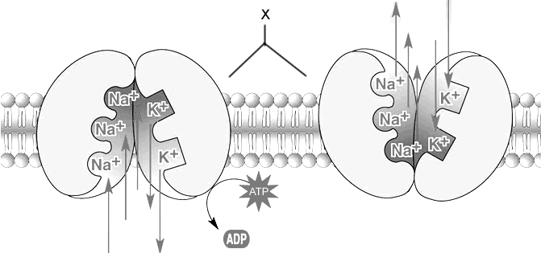
Description _______________________________________________________________________
TITLE: _______________________________________________
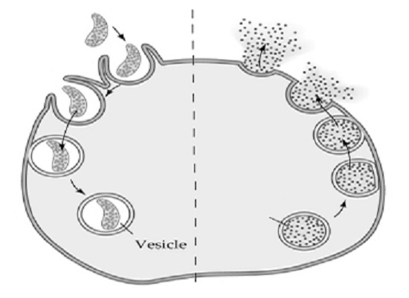
Description _______________________________________________________________________

TITLE: _________________________________________________________
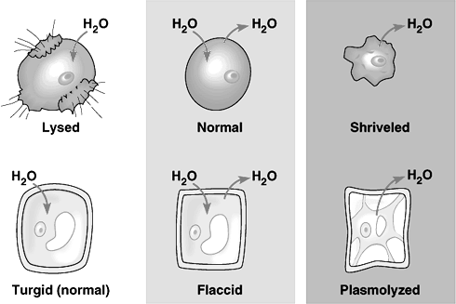
Description _______________________________________________________________________
TITLE: _______________________________________________
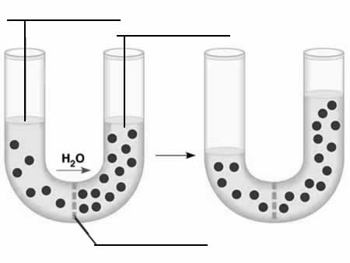
Description _______________________________________________________________________

TITLE: ______________________________________________________
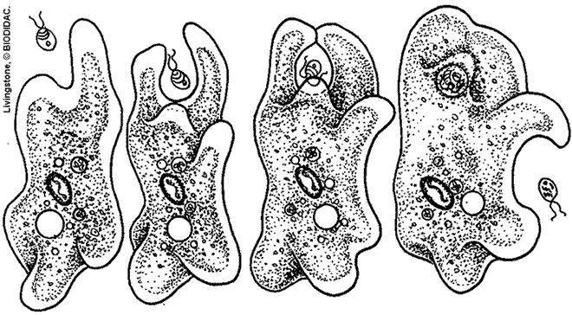
Description _______________________________________________________________________
TITLE: _____________________________________________
