Body Structures
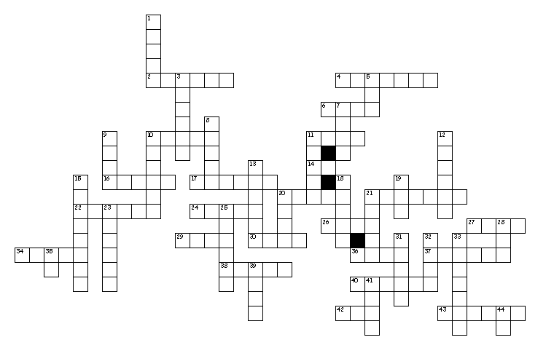

Across
2. enlargement
4. abdomen
6. back side
10. pain
11. spine
14. muscle
16. belly
17. process of recording
20. anterior
21. eyelid
22. head
24. uppermost
26. breathing
27. to print or record
29. large
30. hand
34. recording instrument
36. blue
37. electricity
38. fast
40. movement
42. one
43. posterior
Down
1. twitching
3. large
5. painful
7. condition
8. side
9. pelvis
10. digits
11. body
12. umbilicus
13. chest
15. brain
18. skull
19. distant
20. against
21. slow
23. near
25. surgical repair
28. extremities
31. situated below
32. middle
33. peritoneum
35. toward
39. lower portion of body
41. inflammation
44. inside

