All About Birds

Birds belong to the biological class Aves and live virtually everywhere on Earth because they have evolved endothermy, the ability to use their metabolism to maintain a constant body temperature. Birds probably evolved from meat-eating dinosaurs during the Mesozoic Era, roughly 150 million years ago. Early birds, like Archaeopteryx, had teeth in their mouth and claws on their wings Birds are warm-blooded (endotherms) vertebrate animals that have wings, feathers, a beak, NO teeth, and a skeleton in which many bones are fused together or are absent. They also have an extremely efficient, one-way breathing system with additional air sacs. Flying birds have strong, hollow bones and powerful flight muscles (chicken breast). Most birds can fly. Birds have a very strong heart and an efficient way of breathing. These are necessary for birds to fly. Birds also use a lot of energy while flying and need to eat a lot of food to power their flight.

- In what class are birds grouped?

- Why are birds able to leave virtually everywhere on earth?

- Define endothermy.
- Use your textbook to find the other group of vertebrate that are endotherms.

- From which vertebrate group – fish, amphibians, or reptiles- did birds probably arise?

- During what era did birds emerge?
- List three MAIN structures found in birds.

- Describe a bird’s skeleton

- Why is a bird’s respiratory system so efficient?

- Describe the bones of birds.

Movement
Bird locomotion is quite varied; most can fly, some can run very well, some swim, and some do combinations of these. Label and color the penguin according to the colors shown in the small picture. Some birds cannot fly at all. Those birds that do fly are well adapted for flight. Flying birds' wings are shaped to provide lift, allowing them to fly. These light-weight animals have adapted to their environment by flying, which makes them efficient hunters, lets them escape from hungry predators (like cats), and takes them away from harsh weather (migration). The peregrine falcon is one of the fastest birds, and has been clocked at 90 miles per hour in a dive.
Feathers:
Feathers are highly modified scales. Label and color the feather yellow. Male birds are frequently more brightly colored than females. This is to attract females for mating purposes. The females are more dully colored, helping to camouflage her when she is caring for her young (although the male often cares for the young, with or without the female). The peacock is very brightly colored. The peahen (the female peafowl) is dull brown in color. There are different types of feathers that have different uses.
Feathers are used for:
- Flying - flight feathers, grow in the wings and the tail
- Thermal insulation - soft down feathers that grow close to the skin keep birds from getting too cold or too hot
- Courtship and mating displays - these vary tremendously from species to species
- Do all birds fly? Explain your answer.

- Why are males often bright colors while females are duller in color?

- Feathers are actually modified from what structures?

- Give three functions of feathers.
a.

b.

c.

Modern-day birds have beaks and do not have any teeth (ancient birds did have teeth). Birds have a tongue, but unlike our tongue, a bird's tongue has a bone in it. Birds spend most of their time looking for food. Most birds are insectivores (they eat insects). Some birds, like owls and eagles, are carnivores (meat-eaters). Some birds, like the hummingbird, grouse, and Canada goose, are mostly herbivores (plant-eaters). Label and color the Canada goose as shown. Other birds, like starlings, are omnivores (plant- and meat-eaters). Some birds (like the toucan) are fructivores (fruit-eaters.)
Birds mostly use their keen eyesight to find food. They use their beak and their claws to get bugs, worms, small mammals, fish, fruit, grain, or nectar. Some amazing hunters, like eagles, have eyesight that is five to six times sharper than a person's. They can spot small prey from a mile away. Label and color the eagle below. Birds are economically important as they play a very important part in the natural control of insects and in the dispersal of seeds. Some birds, like the tiny, nectar-eating hummingbird are important pollinators of some flowering plants. Color the hummingbird light green with a red throat. Doves are birds that feed on grain and grass seeds on the ground. Label and color the dove with the eye red, the neck light green, the feathers gray, and the feet and legs pink. Cardinals are found in the city and country. The male is more brightly colored than the female. Label and color the male cardinal as shown.
- Ancient birds had teeth, but modern birds replaced teeth with a ______________.
- How is a bird’s tongue different from ours?
- Complete this table:
Niche | Meaning | Examples of Birds
Insectivores
Carnivores
Herbivores
Omnivores
Fructivores

- What two body structures in birds have been adapted to the type of food they eat?

- Why do most birds have such keen eye sight?

- List 3 economic advantages of birds.
Nests and Eggs:
Birds bear their young in hard-shelled eggs (amniote eggs), which hatch after some time called the incubation period. The length of the incubation period varies among different species of birds. The egg of the ostrich can weigh up to 7 pounds. Some birds, like chickens, lay eggs each day, others (like the Maleo) may go for years between laying eggs. Birds build nests for breeding in trees, on cliffs, or on the ground. Most birds are taken care of by at least one parent until they are able to fly and get their own food. Some birds, like old-world cuckoos and some cowbirds, lay their eggs in other bird's nests. The non-related adult bird takes care of the cuckoo's egg unwittingly. Some cuckoos even kill the other eggs in the nest to insure that their egg gets enough food.
Migration:
Many bird species migrate to a cooler climate for reproducing and summer feeding, and then return to a warmer climate for the winter.
Bird Songs:
Birds sing beautiful and diversified songs. Songbirds have a vocal organ called the syrinx located in the throat. The muscular syrinx has two halves that each vibrates to produce songs, so the bird can sing two notes at a time. To sing, a bird blows air from the lungs through the syrinx.
- Birds lay shelled eggs called _________________ eggs.
- Bird eggs hatch at the end of their _______________ period.
- Which bird lays the heaviest egg?
- How often do chickens lay eggs? The maleo bird?
- Briefly describe nesting and egg laying in birds.
Label the External Bird Anatomy Diagram

Read the definitions, then label and color the external bird (parrot) anatomy diagram below:

Abdomen - the belly (red)  Auriculars (ear coverts) - the feathers that cover the bird's ear opening (located behind the eyes) - white  Breast - the area over the belly and under the throat (red)  Cere - the waxy-looking bumps on the upper beak of some birds (including the parrots, pigeons, and some hawks) white  Claws - hard talons at the end of each toe (black)  Crown - the top of the bird's head (red)  Forehead - the area directly above the eyes (white)  Lore - the area on each side of a bird's face, between the eyes and the upper bill (white)  Lower mandible - the lower part of the bill (light tan)  Nape - the back of the neck (light green) | Primaries - the main flight feathers on the wings (they are located on lower [outer] parts of the wings) – dark green with dark blue tips  Scapulars - feathers on the shoulder (also called lesser secondary coverts) – light green  Secondaries - the smaller flight feathers on the wings - they are on the upper part of the wings (above the primaries) - yellow  Tail feathers - flight feathers at the end of the bird (used for steering) - red  Toes - the digits of the feet dark brown  Throat - the area under head and above the chest (red)  Upper mandible - the upper part of the bill (light tan)  Wing coverts - small feathers that cover the base of larger wing feathers (located at the top of the wings under the scapulars) – dark green

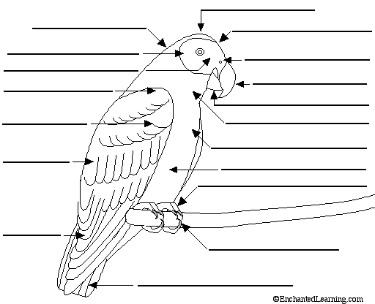

Label the Amniote Egg of the Bird
Read the definitions, then label and color the amniote egg diagram below:

Air cell - an empty space located at the large end of the egg; it is between the inner and outer shell membranes (tan)
Chalaza - a spiral, rope-like strand that anchors the yolk in the thick egg white. There are two chalazae anchoring each yolk --- one on the top and one on the bottom. The plural of chalaza is chalazae - brown
germinal disc or blastodisc - a small, circular, white spot (2-3 mm across) on the surface of the yolk; it is where the sperm enters the egg. The nucleus of the egg is in the blastodisc - red
Inner shell membrane - the thin membrane located between the outer shell membrane and the albumin
Outer shell membrane - the thin membrane located just inside the shell
Shell - the hard, protective coating of the egg. It is semi-permeable; it lets gas exchange occur, but keeps other substances from entering the egg. The shell is made of calcium carbonate
Thick albumin - the stringy part of the egg white (albumin) located nearest the yolk - orange
Thin albumin - the watery part of the egg white (albumin) located farthest from the yolk - pink
Vitelline (yolk) membrane - the membrane that surrounds the yolk
Yolk - the yellow, inner part of the egg where the embryo will form. The yolk contains the food that will nourish the embryo as it grows - yellow

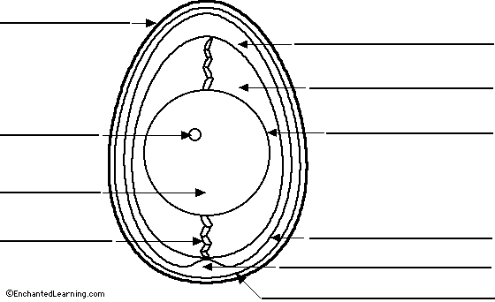

Fill in the term for these definitions:

__________1. Hard, protective coating of the egg
_________ 2. Egg white
_________ 3. Contains the food & where the embryo develops
_________ 4. Membrane surrounding the yolk
_________ 5. Made of calcium carbonate & allows gas exchange
_________ 6. Rope-like strand that anchors the yolk
_________7. Empty space at the large end of an egg
_________8. Claws at the end of each toe
_________9. Small, circular disc where sperm enters the egg
_________10. Small feathers that cover the base of the wing
_________11. Feathers used for steering
_________12. Feathers covering the bird’s ear openings
_________13. Top of the bird’s head
_________14. Main flight feathers
_________15. Back of the neck
_________16. Bird’s bill

