Anatomy of a Bone -Coloring
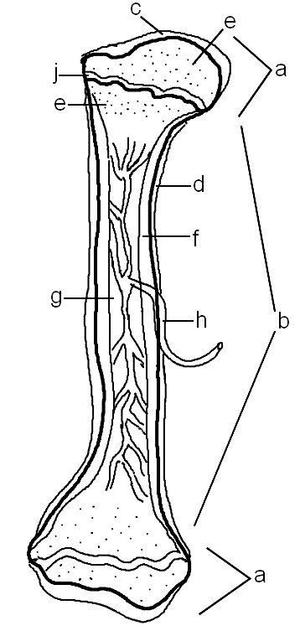
EPIPHYSIS (a) - at the ends of the bone, do not color
The epiphysis has a thin layer of compact bone, while internally the bone is cancellous. The epiphysis is capped with articular cartilage.
EPIPHYSIAL LINE (j) - purple
The epiphysial line or disk is also called the growth plate, it is found on both ends of the long bone.
DIAPHYSIS (shaft) (b) - do not color
The diaphysis is the shaft of the long bone. It has compact bone with a central cavity.
ARTICULAR CARTILAGE (c) - green
The articular cartilage is found on the ends of long bones. It is smooth, slippery, and bloodless. Color both ends.
PERIOSTEUM (d) - dark blue
Periosteum is a vascular, sensitive life support covering for bone. It provides nutrient-rich blood for bone cells and is a source of bone-developing cells during growth or after a fracture. Color both sides, it is the outermost layer.
CANCELLOUS (spongy) BONE (e) and MARROW (e) - light blue
The cancellous bone is found mainly within the epiphysis and has a textured appeareance. Red marrow packs the spaces between beams. Color both ends.
COMPACT BONE (f) - pink
The compact bone is a dense bone found in the diaphysis. Its repeated pattern is arranged in concentric layers of solid bone tissue. The compact bone can be seen as the layer just underneath the periosteum, color both ends.
MEDULLARY CAVITY (g), YELLOW MARROW (g) - yellow
The medullar cavity of the diaphysis serves to lighten bone weight and provide space for marrow. Yellow marrow is associated with fat.
NUTRIENT ARTERY (h) - red
Each long bone contains a tunnel in its shaft for the passage of a nutrient artery, which supplies the shaft. The artery can also be seen within the medullary cavity as branches.
1. Where do you find yellow marrow? __________________________
2. What type of bone is arranged in concentric layers? ______________________
3. Where do you find red marrow? ___________________________
4. What is the end of the bone called? _______________________________
5. Spongy bone is also called ____________________ bone.

