Name:___________________________________________________

Human Physiology

**Anatomy and Physiology of Cells**

**Part 1**: Complete the following table to fully describe the various cell parts.

|  |  |  |
| --- | --- | --- |
| Cell Structure | Location | Function |
|  | External boundary of the cell | Confines cell contents; regulates entry & exit of materials. |
| Lysosome |  |  |
|  | Scattered throughout the cell | Controls release of energy from foods; forms ATP |
|  | Projections of the cell membrane | Increase the membrane surface area |
| Golgi Apparatus |  |  |
| Nucleus |  |  |
|  | Two rod-shaped bodies near the nucleus | Involved in Animal cell mitosis |
| Nucleolus |  |  |
| Smooth ER |  |  |
| Rough ER |  |  |
|  | Attached to membrane systems or scattered in the cytoplasm | Synthesize proteins |

**Part 2**: Using the following list of terms, correctly label all cell parts indicated by leader lines in Figure 3-1. Then select different colors for each structure and use them to color the coding circles and the corresponding structures in the illustration.





**Part 3**: Figure 3.4 shows three microscope fields containing red blood cells. Arrows indicate the direction of net osmosis. Select three different colors and use them to color the coding circles and the corresponding cells in the diagrams. Then, respond to the questions below. Referring to figure 3.4 and inserting you answer in the spaces provided.

Water moves into the cells Water enters and exits the cells at the same rate

Water moves out of the cell

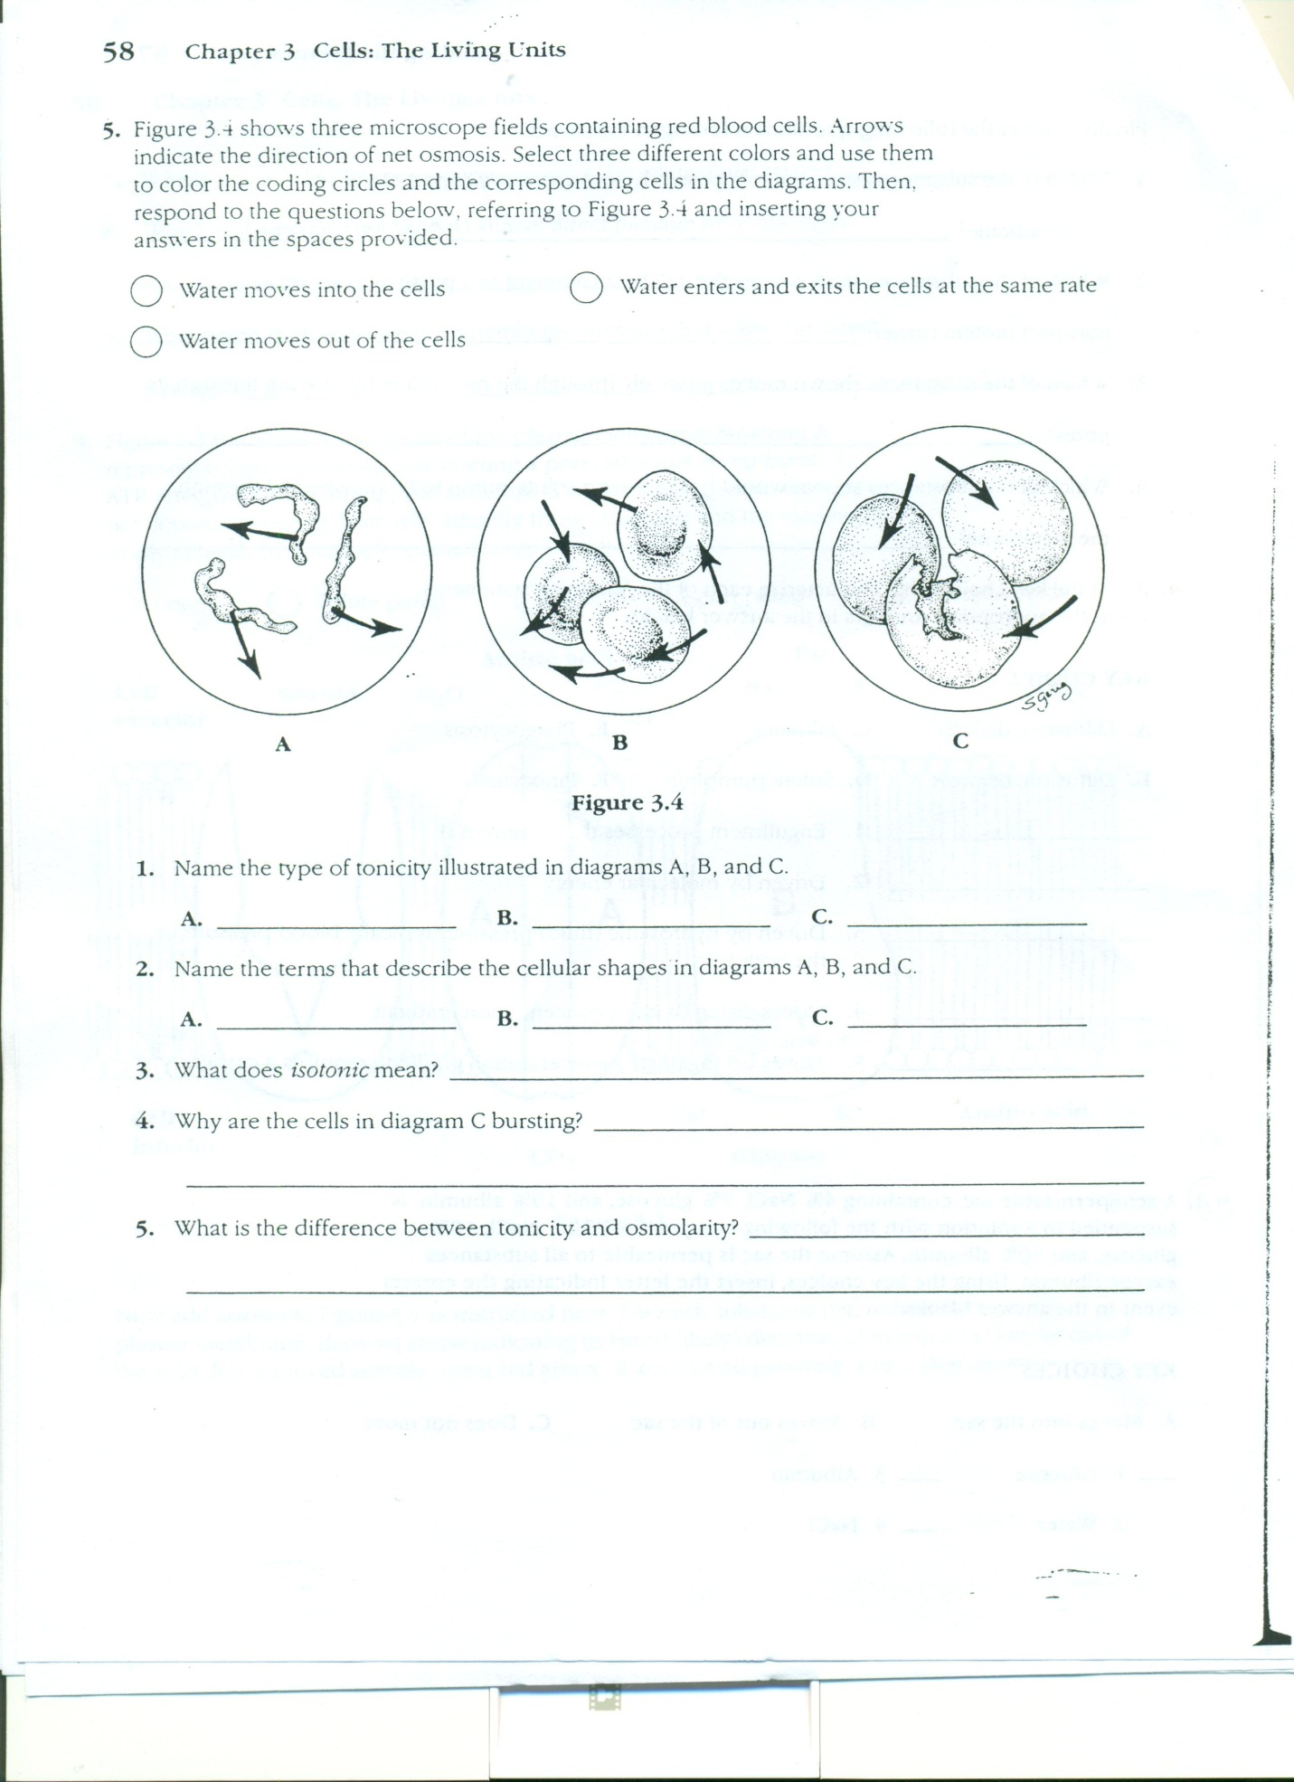

1. Name the type of tonicity illustrated in diagrams A, B, and C.
2. ____________________ B.____________________ C.___________________
3. Name the terms that describe the cellular shapes in diagrams A, B, and C.

A.____________________ B.____________________ C.___________________

1. What does *isotonic* mean? __________________________________________________
2. Why are the cells in diagram C bursting? _____________________________________

________________________________________________________________________

1. What is the difference between tonicity and osmolality? __________________________

________________________________________________________________________________________________________________________________________

**Part 4**: The diagram below shows six cells in various phases of the cell cycle. Note the cells are not arranged in the order in which the cell cycle occurs. Use the diagram to answer questions the following questions.

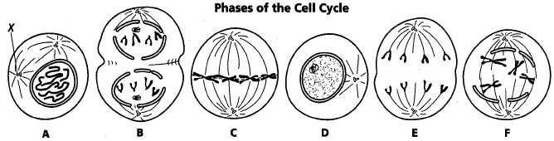

1. Cells A & F show an early and a late stage of the same phase of the cell cycle. What phase is it?

2. Which cell is in metaphase?

3. Which cell is in the first phase of M phase (mitosis)?

4. In cell A, what structure is labeled X?

5. List the diagrams in order from first to last in the cell cycle.

6. What is the longest phase of the cell cycle?

7. Why is mitosis important?

8. Predict what would happen if cytokinesis was skipped.